****

**TRIBHUVAN UNIVERSITY**

**Faculty of Humanities and Social Sciences**

**SHOWGO: AN ONLINE MOVIE**

**TICKET BOOKING SYSTEM**

**A PROJECT REPORT**

**Submitted to**

**Department of Computer Application**

**Prime College**

***In the partial fulfillment of the requirements for the Bachelor’s in Computer Application***

Submitted By:

Yashashwee Pradhan(41002191)  
January 2026 A.D

**Under the supervision of:**  
**Er.Rolisha Sthapit**

****

**TRIBHUVAN UNIVERSITY**

**Faculty of Humanities and Social Sciences**

**Prime College**

# SUPERVISOR'S RECOMMENDATION

I hereby recommend that this project prepared under my supervision by **Yashashwee Pradhan**entitled**"ShowGo : An Online Movie Ticket Booking System"** in the partial fulfillment for the degree of Bachelor of Computer Application is recommended for the final evaluation.

**Er.Rolisha Sthapit  
SUPERVISOR  
Prime College**

****

**TRIBHUVAN UNIVERSITY**

**Faculty of Humanities and Social Sciences**

**Prime College**

# LETTER OF APPROVAL

This is to certify that this project prepared by **Yashashwee Pradhan** entitled **"ShowGo: An Online Movie Ticket Booking System"** in the partial fulfillment for the degree of Bachelor of Computer Application has been evaluated. In our opinion, it is satisfactory in the scope and quality as a project for the required degree.

|  |  |
| --- | --- |
| **Er. Rolisha Sthapit**  **Supervisor**  **Prime College** | **Er. Rolisha Sthapit**  **BCA Co-Ordinator/Internal Examiner**  **Prime College** |
|  | **External Examiner** |

# ABSTRACT

The **Online Movie Ticket Booking System** is a web-based application designed to allow users to conveniently browse movies, view show-time, select seats, and book tickets from anywhere. The system provides two separate interfaces: **User Panel** and **Admin Panel**. Users can sign up, log in, explore available movies, choose show timings, and reserve seats through an interactive booking page. The admin can manage movies, update show schedules, and monitor bookings through a secure administrative dashboard.

The project uses **HTML, CSS, and JavaScript** for the front-end and **PHP with MySQL** for the back-end. User authentication is implemented with secure PHP sessions, and all data such as users, admins, movies, shows, and seats is stored in a MySQL database. This project aims to replace traditional ticket booking by providing a faster, more efficient, and user-friendly online solution. It showcases core concepts of web development, including database connectivity, session management, form handling, and CRUD operations. Ultimately, the system enhances the movie-going experience by providing an accessible and streamlined ticket reservation platform.  
***Keywords:Users, Admin, HTML, Dashboard, CSS, PHP, MySQL, CRUD***

# ACKNOWLEDGMENT

I would like to take this opportunity to express my sincere gratitude and appreciation to everyone who has contributed to the successful completion of this **Online Movie Ticket Booking** System project.

First and foremost, I would like to extend my heartfelt thanks to **Prime College** for providing a supportive learning environment and the platform to explore, develop, and enhance our technical skills.

I am deeply grateful to our supervisor and coordinator, **Er. Rolisha Sthapit**, for her invaluable guidance, continuous support, and encouragement throughout every stage of this project. Her insights and dedication have played a significant role in shaping the outcome of this work.

Lastly, I would like to express my appreciation to everyone who has taken the time to review this report. I hope the information presented here is helpful and offers a clear and comprehensive understanding of the project.

Thank you all for your invaluable contributions.

**Sincerely,**  
**Yashashwee Pradhan**

**TABLE OF CONTENTS**

**[SUPERVISOR'S RECOMMENDATION i](#_Toc216335306)**

**[LETTER OF APPROVAL i](#_Toc216335307)i**

**[ABSTRACT i](#_Toc216335308)ii**

**[ACKNOWLEDGMENT i](#_Toc216335309)v**

**[LIST OF ABBREVIATIONS v](#_Toc216335310)ii**

**[LIST OF TABLES v](#_Toc216335311)iii**

**[LIST OF FIGURES i](#_Toc216335312)x**

**[CHAPTER 1 INTRODUCTION 1](#_Toc216335313)**

[1.1 Introduction 1](#_Toc216335314)

[1.2 Problem Statement 1](#_Toc216335315)

[1.3 Objectives 2](#_Toc216335316)

[1.4 Scopes and Limitations 2](#_Toc216335317)

[1.4.1 Scopes 2](#_Toc216335318)

[1.4.2 Limitations 2](#_Toc216335319)

[1.5 Development Methodology 3](#_Toc216335320)

[1.6 Report Organization 4](#_Toc216335321)

**[CHAPTER 2 BACKGROUND STUDY AND LITERATURE REVIEW 6](#_Toc216335322)**

[2.1 Background Study 6](#_Toc216335323)

[2.2 Literature Review 6](#_Toc216335324)

**[CHAPTER 3 SYSTEM ANALYSIS AND DESIGN 8](#_Toc216335325)**

[3.1 System Analysis 8](#_Toc216335326)

[3.1.1 Requirement Analysis 8](#_Toc216335327)

[3.1.2 Feasibility Study 1](#_Toc216335328)0

[3.1.3 Data Modeling 1](#_Toc216335329)2

[3.1.4 Process Modeling 1](#_Toc216335330)2

[3.2 System Design 1](#_Toc216335331)4

[3.2.1 System Architecture 1](#_Toc216335332)5

[3.2.2 Database Schema Design 1](#_Toc216335333)6

[3.2.3 Interface Design (UI Interface/Interface Structure Diagrams) 1](#_Toc216335334)7

[3.2.4 Physical DFD 1](#_Toc216335335)8

**[CHAPTER 4 IMPLEMENTATION AND TESTING 1](#_Toc216335337)9**

[4.1 Implementation 1](#_Toc216335338)9

[4.1.1 Tools Used 1](#_Toc216335339)9

[4.1.2 Implementation Details of Modules 2](#_Toc216335340)0

[4.2 Testing 2](#_Toc216335341)3

[4.2.1 Unit Testing 2](#_Toc216335342)3

[4.2.2 System Testing 2](#_Toc216335342)4

**[CHAPTER 5 CONCLUSION AND FUTURE RECOMMENDATIONS 2](#_Toc216335343)6**

[5.1 Lessons Learnt / Outcome 2](#_Toc216335344)6

[5.2 Conclusion 2](#_Toc216335345)6

[5.3 Future Recommendations 2](#_Toc216335346)6

**[REFERENCES 2](#_Toc216335347)8**

**[APPENDICES](#_Toc216335348)**

# LIST OF ABBREVIATIONS

**CSS** Cascading Style Sheet

**DFD** Data Flow Diagram

**ERD** Entity Relationship Diagram

**HTML** Hypertext Markup Language

**JS** JavaScript

**PHP** Hypertext Preprocessor

**SQL** Structured Query Language

**RDBMS** Relational Database Management System

**UI** User Interface

**CRUD** Create, Read, Update, Delete

# LIST OF TABLES

[Table 3. 1 Gantt Table 1](#_Toc216429990)1

[Table 4. 1 User Module Test Cases 2](#_Toc216429991)3

[Table 4. 2 Features Module Test Cases 2](#_Toc216429992)4

[Table 4. 3 UI Module Test Cases  2](#_Toc216429993)4

[Table 4. 4 Admin Module Test Cases 2](#_Toc216429994)5

# LIST OF FIGURES

[Figure ‎1.1: Waterfall Software Development Model 3](#_Toc216430024)

[‎Figure 3.1: Use-Case Diagram 8](#_Toc216430025)

[Figure 3.2: Gantt Chart of ShowGo Project 1](#_Toc216430026)1

[Figure ‎3.3: Entity Relationship Diagram of ShowGo 1](#_Toc216430027)2

[Figure ‎3.4: Context Level Diagram (Level 0 DFD) of ShowGo 1](#_Toc216430028)3

[Figure ‎3.5: Context Level 1 Data Flow Diagram 1](#_Toc216430029)4

[Figure 3.6: System Architecture of ShowGo 1](#_Toc216430032)5

[Figure 3.7: Database Schema Design of ShowGo 1](#_Toc216430033)6

[Figure 3.8: Interface Structure Diagram of ShowGo 1](#_Toc216430034)7

Figure 3.9: UI Interface of ShowGo..................................................................................18 Figure 3.10 Physical Diagram of ShowGo……………………………….......….........….18

# CHAPTER 1 INTRODUCTION

## Introduction

The rapid growth of internet technology has significantly changed the way services are accessed and managed. In the entertainment industry, online platforms have become an essential part of modern movie ticket booking systems. The Online Movie Ticket Booking System is a web-based application designed to provide users with a convenient and efficient way to book movie tickets online.

This system allows users to view available movies, check show-time, select preferred seats, and book tickets without the need to visit the theater in person. By automating the ticket booking process, the system helps reduce long queues, saves time, and improves the overall customer experience. Users can access the platform anytime and from anywhere, making ticket booking fast and hassle-free.

The system also includes an admin panel that enables authorized administrators to manage movie details, show schedules, and booking records. This centralized management helps improve accuracy, efficiency, and organization of theater operations. Secure user authentication ensures that only authorized users can access specific system features.

Developed using HTML, CSS, JavaScript, PHP, and MySQL, the Online Movie Ticket Booking System focuses on simplicity, usability, and reliability. The project aims to provide an effective digital solution for movie-goers while supporting theater management in handling bookings and operational tasks efficiently.

## Problem Statement

Traditional movie ticket booking systems rely heavily on manual processes and physical counters, which often lead to long queues, time delays, and inconvenience for customers. Limited access to real-time information about movie schedules, seat availability, and booking status further reduces efficiency and user satisfaction. Customers are required to visit theaters in person to purchase tickets, making the process time-consuming and less accessible.

From the management perspective, handling bookings manually increases the chances of errors, data inconsistency, and difficulty in maintaining records of movies, showtimes, and customer bookings. Managing seat availability, tracking bookings, and generating reports become complex and inefficient without an automated system. Additionally, the lack of centralized control makes it challenging to analyze booking trends and optimize theater operations.

Therefore, there is a need for an Online Movie Ticket Booking System that provides a reliable, user-friendly, and automated platform to streamline the ticket booking process. The system should allow users to book tickets conveniently while enabling administrators to efficiently manage movies, show schedules, and booking records. This solution aims to improve operational efficiency, reduce manual workload, and enhance the overall movie-going experience.

## Objectives

The main objective of the Online Movie Ticket Booking System is to provide a convenient, efficient, and user-friendly platform for booking movie tickets online while improving theater management operations. The specific objectives of the project are as follows:

* To provide user authentication and real-time movie, showtime, and seat information.
* To enable administrators to manage movies, show schedules, and bookings.

## Scopes and Limitations

### Scopes

The Movie Ticket Booking System provides a convenient platform for users to browse movies, check show timings, select seats, and book tickets online. It simplifies the ticketing process, reduces waiting time at theaters, and allows administrators to manage movies, schedules, and bookings efficiently. The system can also generate reports for better business analysis.

### Limitations

* Requires an active internet connection to access and book tickets.
* Payment failures or delays can affect booking confirmation.

## Development Methodology

A development methodology is a systematic framework used in software development to guide the process of creating software or web applications. It provides a structured approach for planning, designing, developing, testing, and delivering a software product. Development methodologies define the processes, tasks, roles, and responsibilities that team members must follow throughout the project life cycle. Various models exist within the Software Development Life Cycle (SDLC), such as the Waterfall model, Prototyping model, and Spiral model, chosen based on the nature and objectives of the software. Since the project requirements were clearly defined and finalized before development, and each phase needed to be completed before moving to the next, the Waterfall model was selected for this project.

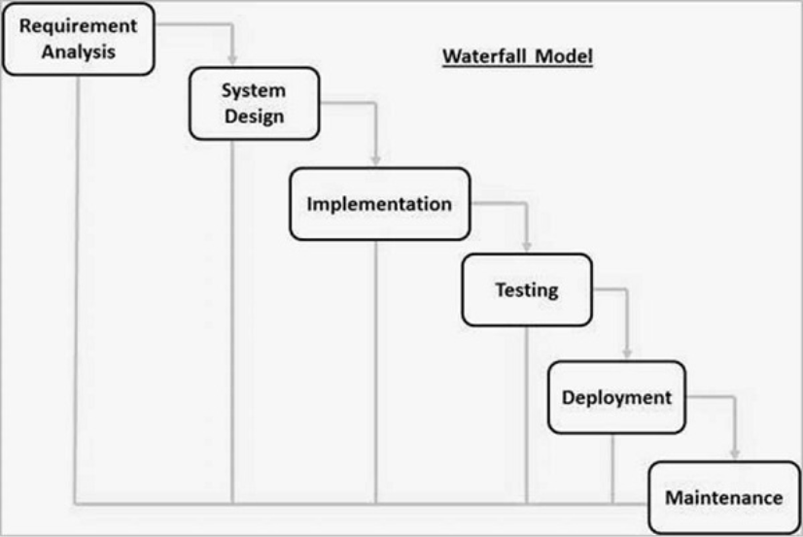

**Figure 1.1: Waterfall Software Development Model [7]**

**Requirement Analysis:** All possible requirements of the system to be developed are captured in this phase. During this step, it was focused on the technical requirement of the project. This includes functional requirements (what the system should do) as well as non-functional requirements (performance, security, scalability, etc.).

**System Design:** Based on the requirements specification, the system design phase focuses on creating the architectural design of the system. This system design helps in specifying hardware and system requirements and helps in defining the overall system architecture.

**Implementation:** With inputs from the system design, the system is first developed in small programs called units, which are integrated in the next phase. Each unit is developed and tested for its functionality, which is referred to as Unit Testing.

**Testing:** Once the implementation is complete, the system undergoes testing to verify that it meets the specified requirements. All the units developed in the implementation phase are integrated into a system after testing of each unit. Post integration the entire system is tested for any faults and failures.

**Deployment and Maintenance:** There are some issues which come up in the client environment. To fix those issues, patches are released. Also to enhance the product some better versions are released. Maintenance is done to deliver these changes in the customer environment.

## Report Organization

Chapter 1 introduces the Movie Ticket Booking System, emphasizing the convenience of booking movie tickets online and checking show timings. It presents the problem statement, outlines the organization of the report, objectives, scope, and project limitations, and describes the methodology used for system development.

Chapter 2 presents the background study related to online ticket booking systems and their importance in the modern digital environment. It also includes a literature review of similar existing systems and platforms, highlighting their features, strengths, and limitations. This chapter helps in understanding current practices and justifies the need for the proposed system.

Chapter 3 focuses on the detailed analysis and design of the system. It includes requirement analysis, feasibility study, data modeling, and process modeling. Various diagrams such as Use Case Diagram, Entity Relationship Diagram (ERD), Data Flow Diagrams (DFD), system architecture, database schema design, and interface design are presented to explain the structure and functionality of the system clearly.

Chapter 4 describes the actual implementation of the system using selected front-end and back-end technologies. It explains the tools used and provides details of different system modules. The chapter also discusses testing strategies, including unit testing and system testing, along with test cases and results to ensure system reliability and correctness.

Chapter 5 summarizes the development and outcomes of the “ShowGo: Online Movie Ticket Booking System.” The project meets its objectives by providing a user-friendly platform for online ticket booking and efficient administrative management. It enhanced understanding of web development, system design, and database management. The system improves user convenience and reduces manual workload for theaters. Future enhancements such as advanced payment options, mobile application support, and improved reporting features can further improve usability and performance.

# CHAPTER 2 BACKGROUND STUDY AND LITERATURE REVIEW

## 2.1 Background Study

The internet has become increasingly popular due to its efficiency and accessibility, giving rise to e-commerce and online services. One such service is online ticket booking, which allows customers to purchase movie tickets via the internet. With widespread internet access and the availability of electronic devices, there has been a notable shift in consumer behavior toward online bookings for entertainment, including movies. This trend is driven by the convenience, speed, and variety of options offered by online ticketing platforms.

The movie ticket booking system allows customers to browse available movies, check show timings, select seats, and book tickets without the need to visit a theater physically. Users can log in from any device with internet access, view movie details, and make bookings efficiently. This significantly reduces waiting times, eliminates the hassle of standing in queues, and makes the entire process more streamlined.

For theater owners and administrators, the system simplifies management by keeping track of movies, schedules, bookings, and payments. It helps save time and labor while ensuring accurate record-keeping. Overall, the movie ticket booking system provides a convenient and organized solution that benefits both customers and theater management.

## 2.2 Literature Review

Ranjana Cineplex: Ranjana Cineplex provides an online platform for booking movie tickets in Nepal. The system allows users to view movie listings, select show-time, and book seats online. Its interface emphasizes ease of use and quick access to available shows, demonstrating the importance of a user-friendly design for customer satisfaction.[1]

Big Movies: Big Movies offers an online ticketing system that enables users to browse theaters, movies, and show timings in Nepal. The platform includes features like seat selection and online payment, ensuring a smooth booking process. Literature indicates that such systems improve convenience for customers while reducing manual workload at ticket counters.[2]

QFX Cinemas:  QFX Cinemas provides both web-based and mobile solutions for movie ticket booking. The system includes seat selection, real-time availability updates, and secure payment options. Studies suggest that real-time updates and secure transaction handling are crucial to maintain reliability and customer trust.[3]

“Design and Implementation of an Online Movie Ticket Booking System”— This paper presents the architectural design and development of a web-based movie ticket booking platform, outlining key components such as user interface, database structure, booking workflow, security measures, and implementation challenges. The focus is on creating a user-friendly, efficient system that automates cinema ticket purchases and enhances convenience for customers by replacing manual queuing with online reservation features.[4]

“A Web-Based Ticket Reservation System for Multiplex Theatres”— This conference paper investigates the creation of an online booking system tailored for multiplex cinema environments, emphasizing practical implementation strategies, real-time seat availability, and reservation management. It discusses system modules supporting show listings, seat selection, and integration with payment gateways to improve operational efficiency and customer experience, particularly in high-traffic theatre settings.[5]

“User-centric Design for Film Ticket Booking Applications”*—* This research article examines how user experience and user-centered design principles are applied to movie ticket booking applications. It reviews interface design considerations, usability testing, and features that address user needs (e.g., intuitive navigation, clear seat maps, fast checkout) to ensure that the system aligns with customers’ goals and reduces friction in the booking process. The study highlights design choices that prioritize ease of use and accessibility for diverse users.[6]

# CHAPTER 3 SYSTEM ANALYSIS AND DESIGN

## 3.1 System Analysis

System analysis is one of the significant phases in the software development process. It deals with studying and making sense out of the proposed software system requirements and specifications. It is the process of studying, identifying, and defining what the intended users and other stakeholders want from a new or existing system. The principal aim of the system analysis is to make sure that the software system built will meet the desired objectives. It also ensures that the system will effectively address the identified needs.

### 3.1.1 Requirement Analysis

**i. Functional Requirement**

The Movie Ticket Booking System allows users to register and log in, view available movies and show timings, select seats, book tickets, and make online payments. It also provides booking confirmation and allows users to view their booking details. Administrators can manage movies, show schedules, ticket prices, and booking records to ensure smooth system operation.

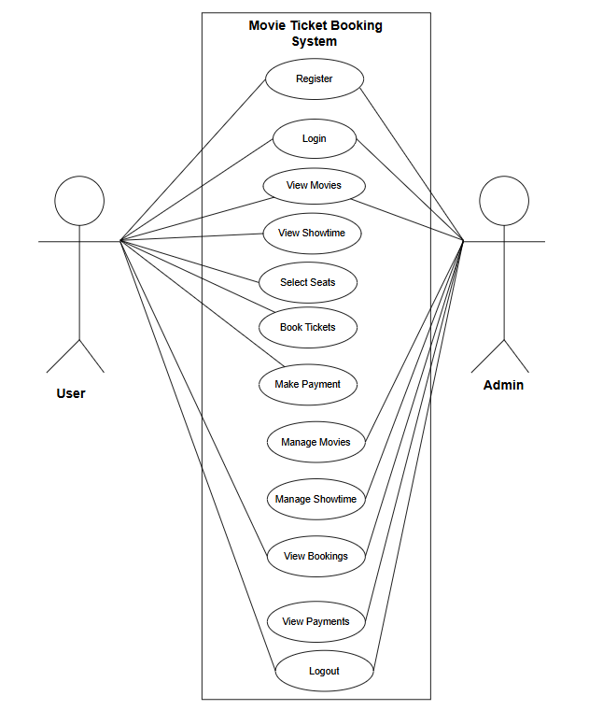

Figure ‎3.1: Use-Case Diagram

**Admin:** Admin must be authenticated before accessing system. They’ll able to access admin dashboard.

**Users:** Users will be able to view/movies, seat layout and showtime on the website. Also, they can register on the website/. They can’t book tickets without logging in to the system.

**Register/Login:** Creates an account with email and password to save details and booking history. We can log in whenever we can return to access the account.

**View Movies:** Users can browse all available movies with posters, titles and showtimes and also see what’s now showing and coming soon.

**View Showtime:** Users can pick available screening times for selected movies including time they wanna watch.

**Book Tickets:** Users can confirm the selection: movie,seats and number of tickets and they’ll get a booking confirmation with a unique ticket id.

**Make Payment:** Users can pay for their tickets and will receive e-tickets once payment is successful.

**Manage Movies (Admins only):** Admins can add new movies, update details, remove old ones and control what appears in the movie listings.

**Manage Showtime (Admins only):** Admins can setup movie schedules, adjust showtime and manage theaters.

**View Bookings:** Users can see their own bookings history. Admins can view all bookings in the system for tracking and management.

**View Payments(Admins only):** Admins can monitor all transactions, track revenue and manage financial records.  
**ii. Non-functional Requirements**

**Usability**The system should be easy to use with a simple and intuitive interface so that users of all age groups can browse movies, select seats, and book tickets without difficulty.

**Performance**The system must respond quickly to user actions such as loading movie lists, showing seat availability, and confirming bookings, even during peak hours.

**Security**The system should protect user data and payment information by using secure authentication and encryption methods to prevent unauthorized access.

**Reliability**The system should function consistently without errors and ensure accurate seat allocation and booking confirmation to avoid double booking.

**Availability**The system should be available 24/7 with minimal downtime so users can book tickets at any time.

### 3.1.2 Feasibility Study

A feasibility study is conducted to evaluate whether the Movie Ticket Booking System can be developed and implemented successfully. It analyzes technical, economic, operational, and schedule feasibility to determine the practicality of the project.

1. **Technical Feasibility**The system is technically feasible as it can be developed using widely available technologies such as HTML, CSS, PHP, and MySQL. These technologies are reliable, cost-effective, and well-supported. The required hardware and software resources are easily accessible, and developers possess the necessary technical skills to implement the system.
2. **Economic Feasibility**The project is economically feasible since it requires minimal development and operational costs. Open-source tools and technologies reduce expenses, while online ticket booking helps theaters reduce manpower costs and increase revenue through efficient ticket sales.
3. **Operational Feasibility**The system is operationally feasible as it simplifies ticket booking for customers and reduces workload for theater staff. Users can easily adapt to the system due to its user-friendly interface, and administrators can manage movies, schedules, and bookings efficiently.
4. **Schedule Feasibility**The project is feasible within the given time frame as the system follows a structured development methodology. Clearly defined requirements and proper planning ensure timely completion of all development phases.

Table 3.1: Gantt Chart Schedule

|  |  |  |  |
| --- | --- | --- | --- |
| **Tasks** | **Start Date** | **Duration(Days)** | **End Date** |
| Documentation | October 2, 2025 | 92 | January 2, 2026 |
| Requirement Analysis | October 2, 2025 | 8 | October 9, 2025 |
| System Design | October 10, 2025 | 11 | October 20, 2025 |
| Implementation | October 21, 2025 | 26 | November 15, 2025 |
| Testing | November 16, 2025 | 11 | November 26, 2025 |
| Deployment | November 27, 2025 | 8 | December 8, 2025 |

.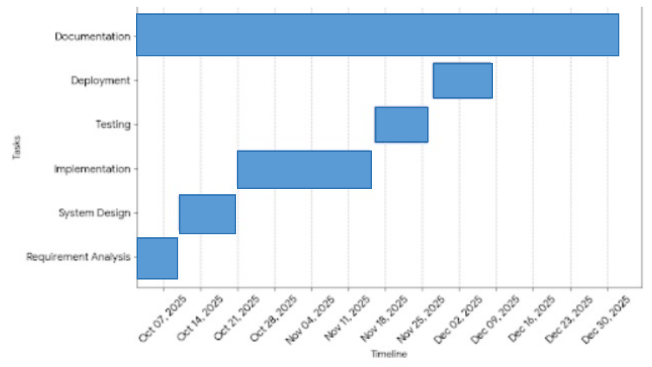

Figure 3.2: Gantt Chart of ShowGo Project

### 3.1.3 Data Modeling

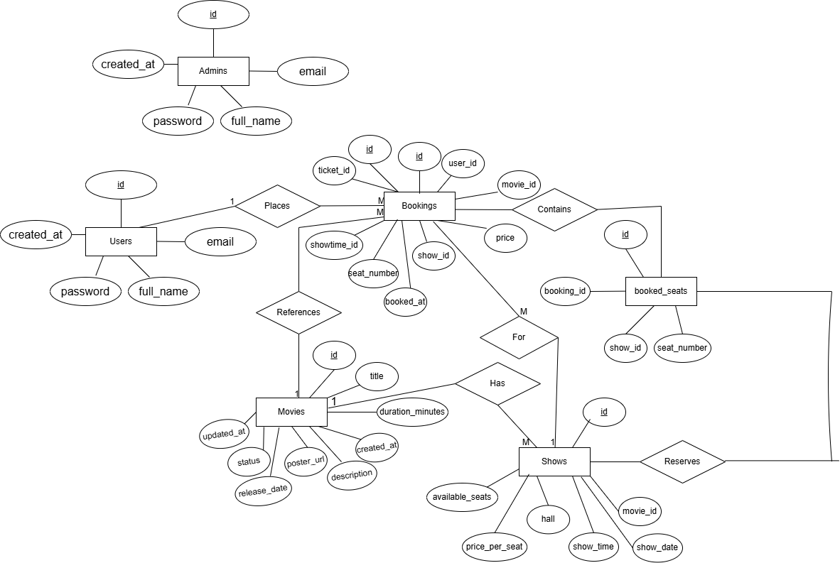

Figure ‎3.3: Entity Relationship Diagram of ShowGo

Figure 3.3 ER diagram is a diagram visually illustrates the major functional requirements of the Online Movie Ticket Booking System and how the primary users, the User and the Admin, interact with it. The User can log in, browse movies and showtimes, view details, select seats, book a ticket, view their booking history, and log out. The Admin is responsible for system maintenance and content management, including logging in, adding or editing movies, scheduling movies, updating show details, and viewing bookings. The core function, Book Ticket, is central to the customer experience, often relying on other steps like seat selection.

### 3.1.4 Process Modeling

Process Modeling describes how data flows and operations are carried out within the Movie Ticket Booking System. It illustrates the interaction between users, the system, and administrators during various activities such as movie browsing, seat selection, ticket booking, and payment processing.

In this system, users search for movies, select show timings and seats, and complete ticket bookings through online payment. The system processes user requests, checks seat availability, confirms bookings, and stores transaction details in the database. Administrators manage movies, schedules, and bookings through the system. Process modeling helps in understanding system functionality, identifying process flow clearly, and ensuring efficient and error-free operations.

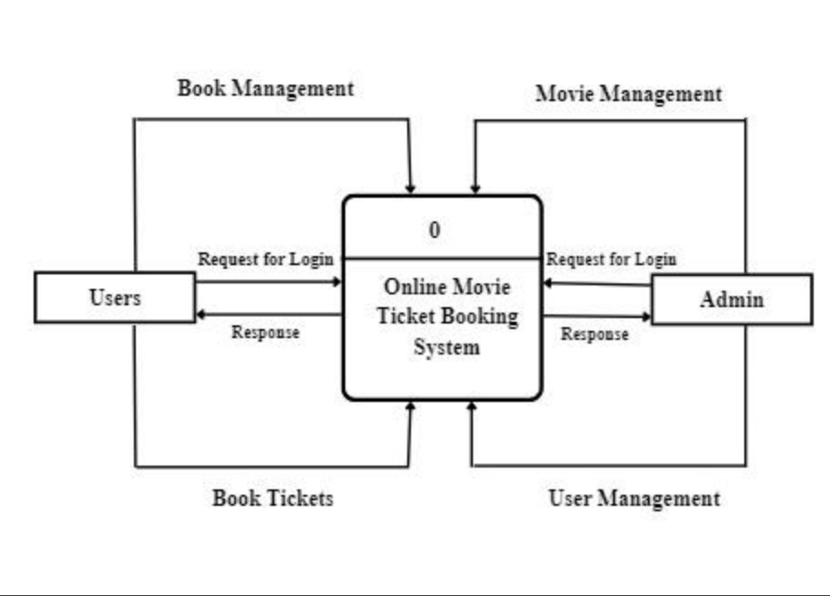

Figure 3.4: Context Level Diagram (Level 0 DFD) of ShowGo

Figure 3.4 represents a Level 0 Data Flow Diagram (DFD) of the Online Movie Ticket Booking System. It shows the system as a central process interacting with two external entities: Users and Admin. Users send login requests to the system and receive responses, and they can book movie tickets through the system. The Admin also sends login requests and receives responses, and is responsible for movie management and user management. Overall, the diagram illustrates the basic flow of information between users, administrators, and the movie ticket booking system.

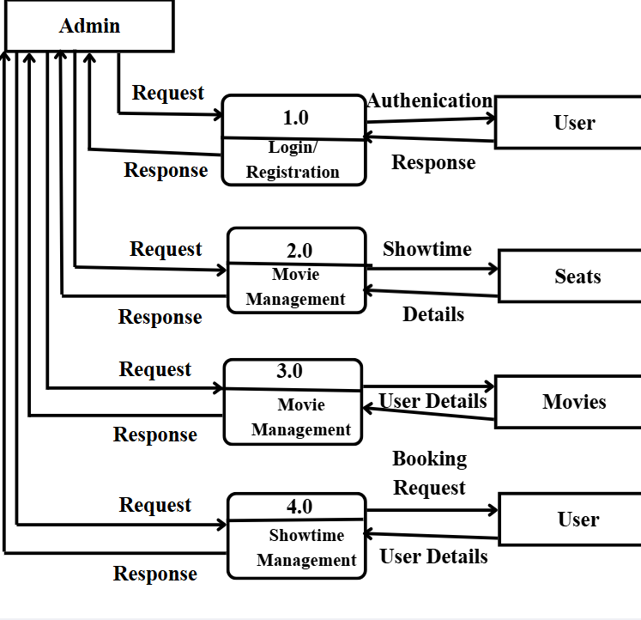

Figure 3.5: Context Level 1 Data Flow Diagram

Figure 3.5 illustrates a Level 1 Data Flow Diagram (DFD) of the Online Movie Ticket Booking System. It shows how the system is divided into major processes such as user authentication, movie information management, ticket booking, user profile management, and viewing bookings. Users interact with the system to log in, view movies, book tickets, and check booking history, while the admin manages movies, users, and booking records. The diagram also shows data stores like user/admin details, movie and show details, and booking records, explaining how data flows between users, administrators, and the system in a structured manner.

## 3.2 System Design

Systems design is the process of defining a system's components, including modules, architecture, components, their interfaces, and data, depending on the requirements that have been given. Design is the bridge between system analysis and system implementation. Several designs were created in the design phase of the project such as system architecture, database schema design, UI Interface and Interface Structure diagram, physical DFD.

### 3.2.1 System Architecture

The system architecture of Online Movie Ticket Booking System can be divided into three main layers: presentation layer, application layer, and database layer.

**Presentation Layer:** In presentation tier, it receives requests from clients and provide them with information. It uses a web browser to interact with other layers and displays output there. Web-based layers are created using programming languages like HTML for the structure, CSS for styling, and JavaScript for interactivity and dynamic behavior. Together, these technologies enable the creation of responsive and intuitive interfaces that enhance user interaction.

**Application Layer:** In application tier, the request obtained through the presentation layer is processed in-depth in this tier of the architecture, which is also known as the logic tier. Additionally, it communicates with the server that hosts the data. The client's request is processed, formatted, and sent back to the client. We’ve used PHP language in the development which facilitate robust and secure processing of data and implementation of business logic.

**Database Layer:** The last tier of the architecture, commonly referred to as the database tier, is the data tier. This layer is responsible for storing all the data related to the online bookstore system. In order to make the processed data retrievable at a later time, it is employed to store the data. It is designed using a database management system such as MySQL.

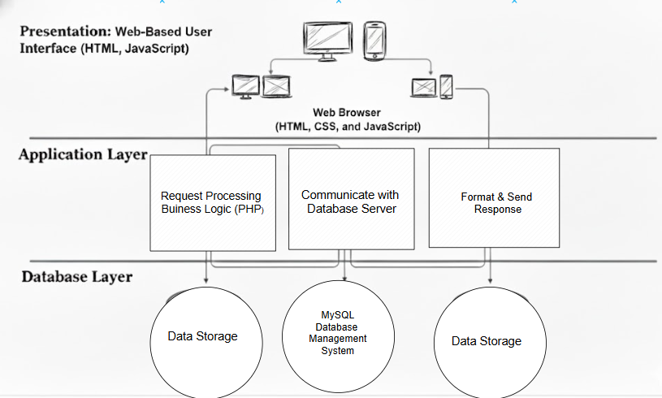

Figure ‎3.6: System Architecture of ShowGo

Figure 3.6 shows the three-tier architecture of the Movie Ticket Booking System. In the Presentation Layer, users interact through a web browser to browse movies and book tickets. The Application Layer, powered by a web server, handles all logic like seat selection and payment processing. The Database Layer uses a MySQL database to store movie details, showtimes, bookings, and user information. This separation makes the system fast, secure, and easy to scale.

### 3.2.2 Database Schema Design

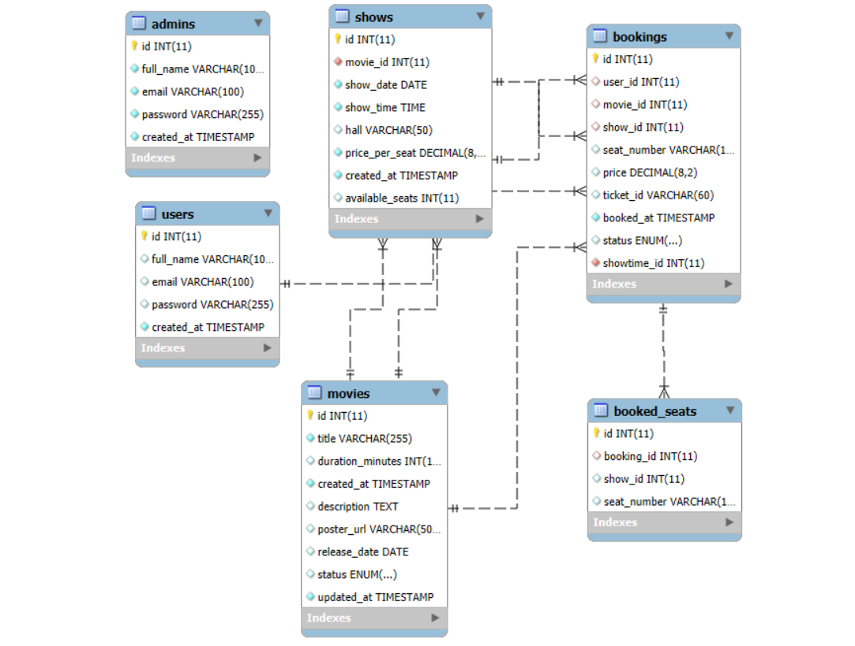

Figure 3.7: Database Schema Design of ShowGo

This database serves as the digital brain behind a movie booking platform, organizing everything from movie schedules to user transactions in a clear, logical way. It begins with the admins table, which keeps track of staff credentials used to manage the movies library and their specific screenings. These movies flow into the shows table, a central hub that assigns a movie to a specific hall, date and price. On the other side, the users table stores customer details, allowing them to browse and select their movies. Finally, the bookings table acts as a detailed transaction record, linking a specific person to their chosen show and seat number to generate a unique ticket identity for the big screen.

### 3.2.3 Interface Design (UI Interface/Interface Structure Diagrams)

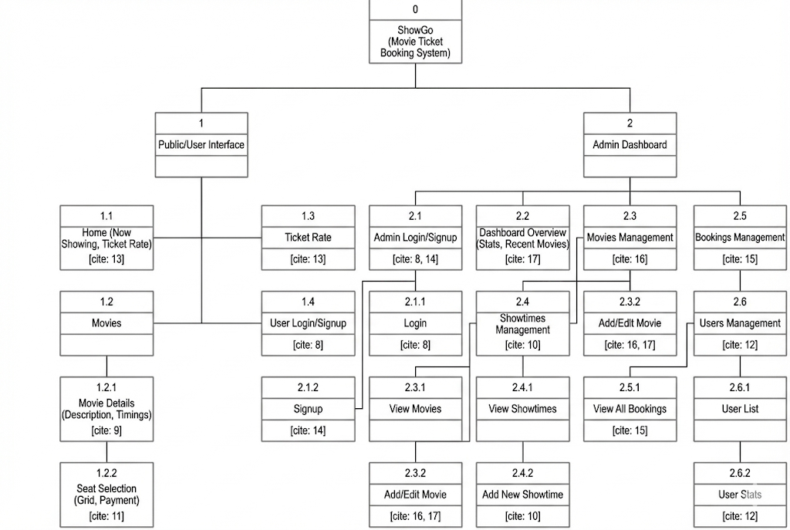

Figure 3.8: Interface Structure Diagram of ShowGo

The site map for Online Movie Ticket Booking System presents a simple and well-organized navigation structure with main sections such as the User Interface and the Admin Dashboard. The User Interface allows users to browse "Now Showing" films, view specific movie details and timings, and perform seat selection through a grid-based payment system, while the user account section provides essential options for login and registration. The Admin Dashboard includes comprehensive features for managing movie catalogs, showtimes, customer bookings, and user statistics, all of which are supported by a backend database that meticulously tracks every film, showtime, and seat transaction. This clear structure ensures easy navigation and smooth interaction for both moviegoers and theater administrators within the Online Movie Ticket Booking System.

**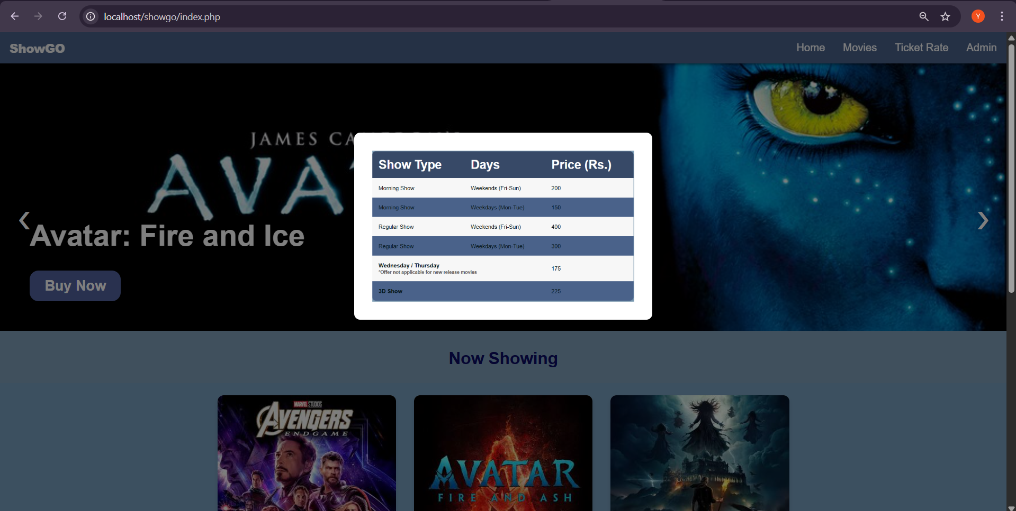**

**Figure 3.9 UI Interface of Online Movie Ticket Booking System**

### 3.2.4 Physical DFD

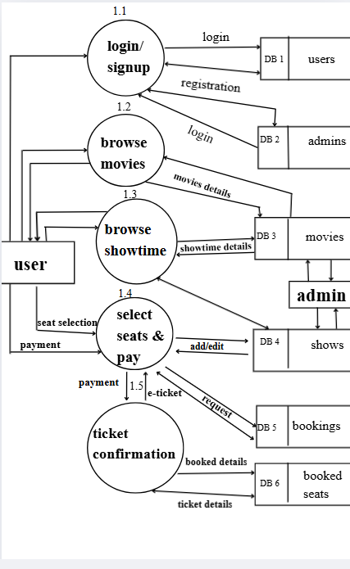

**Figure 3.10: Physical Data Flow Diagram of ShowGo**

Unlike logical DFDs, which focus on the system’s functionality, physical DFDs provide a detailed view of the system's implementation, showing the actual components and devices involved in the data flow.

# CHAPTER 4 IMPLEMENTATION AND TESTING

## 4.1 Implementation

### 4.1.1 Tools Used

**Front-end Tools**

**HTML:**

HTML is the standard markup language that is used to design the structure and content of this application. This tool has been used in the project for displaying text, images, and other form of multimedia on the web-page.

**CSS:**

CSS is used in this page to provide the visual style to the pages. It has been used in this project to create a consistent look which can improve user experience. It used to control the layout, font, color and visualize the aspect of project.

**JavaScript:**

JavaScript web framework is one of the best ways to stack back-end and front-end frameworks and has been used for the same in the project. It has been used for adding interactivity to the user interface, validate user input and perform calculations in this project.

**Back-end Tools**

**PHP:**

It is a server-side scripting language that is used to create a dynamic web page which can interact with databases. It has been useful to handle the server-side processing of data, such as storing and retrieving data from the database like MySQL.

**MySQL:**

MySQL is an open-source relational database management system (RDBMS). It is used MySQL to store and manage data related to books. It is being used in this project to perform operations like data insertion, deletion, and modification.

### 4.1.2 Implementation Details of Modules

There are different modules descriptions. They are described below:

### **Login Module**

The Login Module serves as the secure gateway to the platform. It authenticates a user's identity by validating their credentials typically a username/email and password against the stored database records. Upon successful verification, the system generates a secure session token and grants the user access to functionalities appropriate to their role. This module ensures that only authorized individuals can access personal accounts, manage bookings, or administer cinema operations, maintaining the security and integrity of user data.

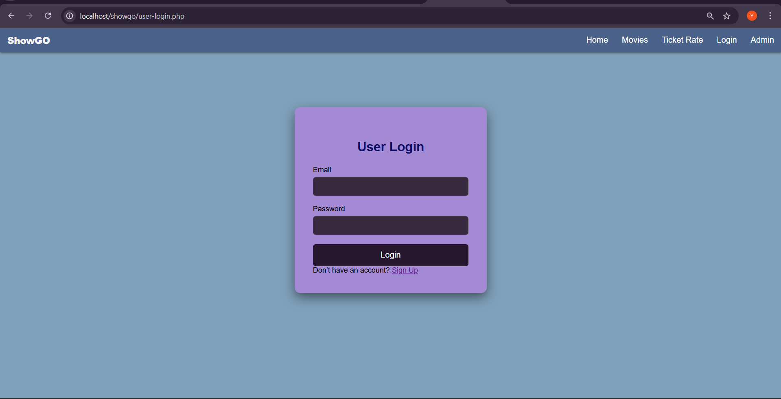

### **Admin Module**

This module is the administrative control center for cinema partners. It allows authorized staff to manage the entire cinematic catalog by adding new movie listings, updating showtimes, and adjusting ticket pricing. Key functions include editing film details, scheduling screenings across different auditoriums, and marking movies as now showing or coming soon. This centralized management ensures the information presented to customers in the booking interface is accurate, up-to-date, and synchronized across all platforms.

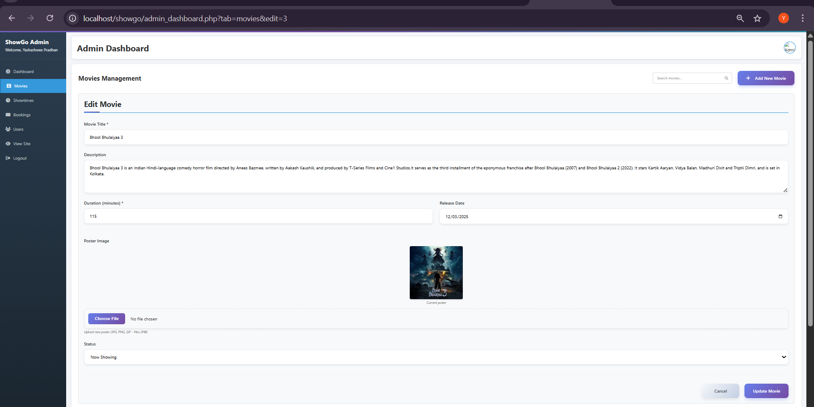

### **Ticket Booking Module**

The Ticket Booking Module provides the core customer-facing experience. It enables users to browse available movies, select a preferred showtime and venue, and choose specific seats from an interactive auditorium layout. The module displays real-time seat availability, calculates the total cost, and holds the selected seats temporarily during the booking process. It acts as the digital replacement for the physical box office, offering a streamlined and intuitive interface for users to secure their reservations before proceeding to payment.

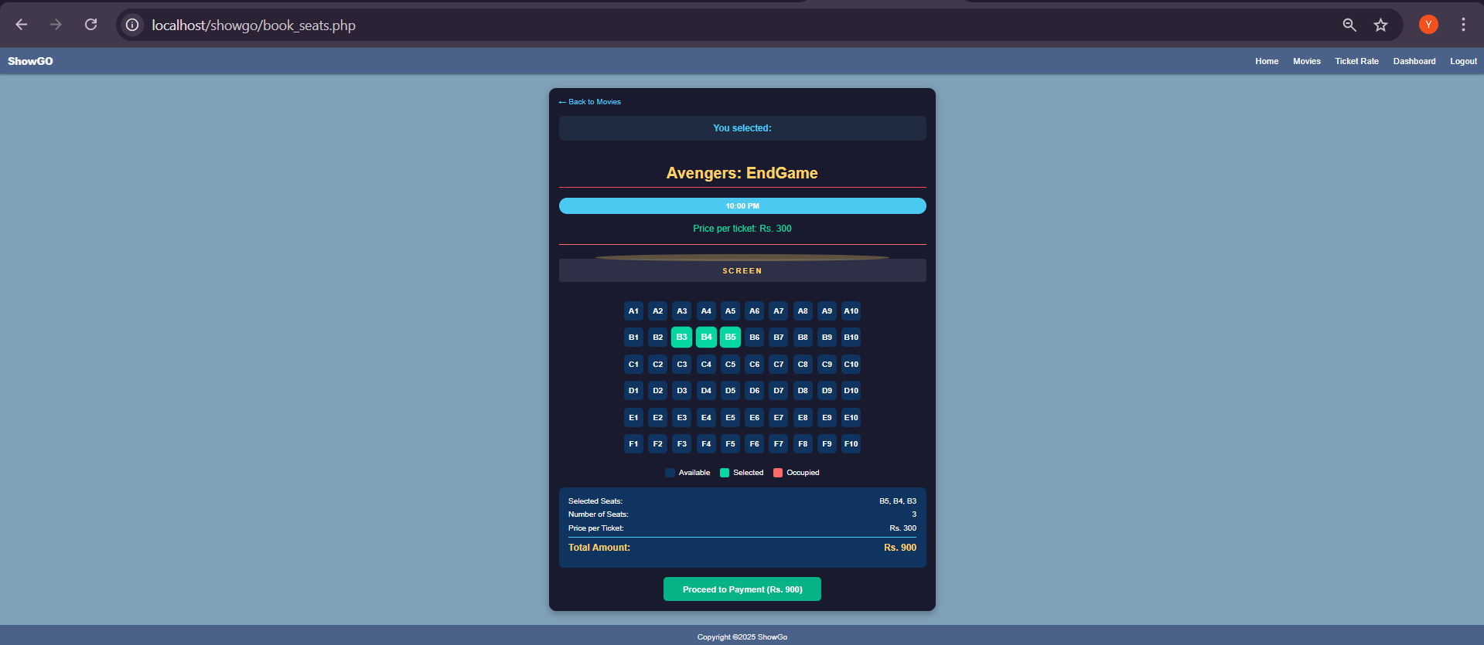

### **Payment Processing Module**

The Payment Processing Module handles the secure financial transaction to finalize a booking. It integrates with payment. The module encrypts sensitive payment information, authorizes the transaction, and communicates the success or failure status back to the system. Upon successful payment, it triggers the generation of a confirmed ticket id and an electronic ticket (e-ticket), completing the purchase cycle and ensuring a seamless, trustworthy checkout experience.

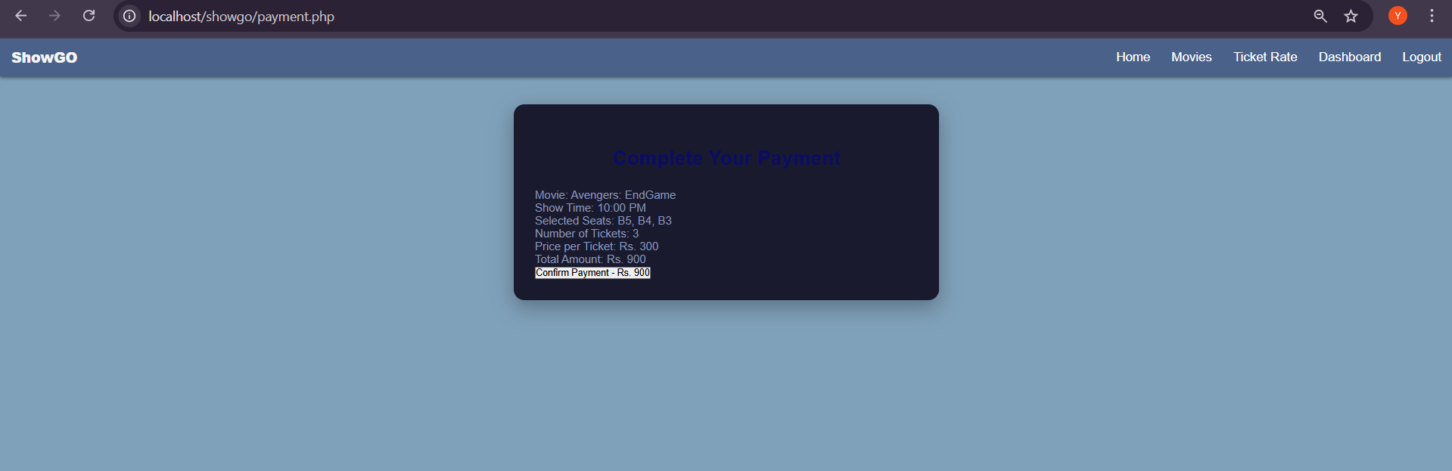

### **5. Registration Module**

The Registration Module facilitates the onboarding of new users to the platform. It collects and verifies essential personal information, such as name, email, to create a secure user profile. This process enables individuals to establish their unique identity within the system, which is a prerequisite for accessing personalized features like ticket booking and viewing booking history. For cinema administrators, a separate registration stream captures business details to grant them backend management privileges.

### **user_signup**

# 4.2 Testing

Testing is the process of detecting the errors. It performs a very crucial role for quality assurance and for ensuring the reliability of the software. The results of testing are used later during maintenance also. Testing requires a lot of time and labor.

### 4.2.1 Unit Testing

Unit testing is a software testing process in which the smallest testable parts of an application, known as units, are tested individually to ensure they function correctly. The Movie Ticket Booking System consists of various individual components that are tested separately. For example, login forms are tested to verify valid and invalid credentials, seat selection buttons are tested to ensure seats are correctly selected and unavailable seats cannot be booked, and the booking confirmation function is tested to confirm tickets are generated only after successful payment. Unit testing helps identify errors at an early stage and ensures that each module of the system performs its intended task accurately. Some of the test cases are:

**Table ‎4.1: User Module Test Cases**

|  |  |  |  |  |
| --- | --- | --- | --- | --- |
| **S.N** | **Test Case Description** | **Input** | **Expected Output** | **Test Result** |
| 1 | Verify user login with valid creditals | Valid email and password | User logged in successfully | Pass |
| 2 | Verify user login with invalid credentials | Invalid email and password | Error message displayed | Pass |
| 3 | Verify user registration | Valid user details | Account created successfully | Pass |
| 4 | View booking history | User dashboard request | Booking history displayed | Pass |

Table ‎4.2 Features Module Test Cases

|  |  |  |  |  |
| --- | --- | --- | --- | --- |
| **S.N** | **Test Case Description** | **Input** | **Expected Output** | **Test Result** |
| 1 | Display available movies | Load movie list page | Movie and show timing displayed | Pass |
| 2 | Verify seat selection | Select available seats | Seat selected successfully | Pass |
| 3 | Prevent booking of booked seats | Select unavailable seats | Seat selection denied | Pass |
| 4 | Confirm ticket booking | Movie show, seat selected | Booking confirmed | Pass |
| 5 | Display ticket receipt after payment | Click confirm payment | Show receipt | Pass |

# 4.2.2 System testing

System testing is a type of software testing that evaluates the overall functionality and performance of a complete and fully integrated software solution.

**Table 4.3 UI Module Test Cases**

|  |  |  |  |  |
| --- | --- | --- | --- | --- |
| **S.N** | **Test Case Description** | **Input** | **Expected Output** | **Test Result** |
| 1 | Verify form validation | Submit empty fields | Validation message displayed | Pass |
| 2 | Verify navigation links | Click menu links | Correct page loaded | Pass |
| 3 | Check button responsiveness | Clicking booking button | Correct action performed | Pass |
| 4 | Check mobile responsiveness | Resize screen | Layout adjusts properly | Pass |

**Table 4.4 Admin Module Test Cases**

|  |  |  |  |  |
| --- | --- | --- | --- | --- |
| **S.N** | **Test Case Description** | **Input** | **Expected Output** | **Test Result** |
| 1 | Admin login verification | Valid admin creditals | Admin logged in successfully | Pass |
| 2 | Add movie details | New movie information | Movie added successfully | Pass |
| 3 | Update movie details | Modified movie information | Movie updated successfully | Pass |
| 4 | Delete movie | Select movie to delete | Movie deleted successfully | Pass |
| 5 | Manage user accounts | Update/delete user | Changes saved successfully | Pass |
| 6 | View booking reports | Report request | Booking report displayed | Pass |

# CHAPTER 5 CONCLUSION AND FUTURE RECOMMENDATIONS

## 5.1 Lessons Learnt / Outcome

Developing the movie ticket booking System provided valuable learning experiences. The author learned that creating a simple and user-friendly interface is essential, as users want to browse movies, select seats, and book tickets quickly without confusion. Implementing clear movie listings, show timings, and seat layouts greatly improves user experience. The importance of mobile responsiveness was also realized, since many users prefer booking tickets through smartphones. Ensuring a secure and reliable payment process was another key learning outcome. Additionally, maintaining real-time seat availability and accurate booking records is crucial to avoid double booking. These lessons contributed to making the system more efficient and reliable.

## 5.2 Conclusion

This project focused on developing a web-based movie ticket Booking System that allows users to book movie tickets online in a simple and convenient manner. The primary objective of this project was to apply fundamental web technologies and develop a functional, user-friendly, and visually appealing system.

The system enables users to view movies, check show timings, select seats, and make online payments, while allowing administrators to manage movies, schedules, and bookings. Although the system successfully meets the initial project requirements, there is still room for further enhancement to improve performance, usability, and additional features. This project helped strengthen the author’s understanding of web development concepts and system design.

## 5.3 Future Recommendations

To further enhance the movie ticket booking system, several improvements can be considered in the future:

**User Feedback and Reviews:**  
Integrate a feedback and rating system so users can share their experiences and rate movies and theaters, helping other users make better decisions.

**Expanded Payment Options:**  
Include multiple payment gateways such as digital wallets, mobile banking, and card payments to provide flexibility and convenience for users.

**Mobile Application Integration:**  
Develop a dedicated mobile application to improve accessibility and provide push notifications for movie releases, offers, and booking confirmations.

**Advanced Seat Management:**  
Implement smarter seat allocation and real-time synchronization across platforms to prevent booking conflicts during peak hours.

**Multi-Language Support:**  
 Add support for multiple languages to make the system more accessible to a wider range of users.

# REFERENCES

[1] Ranjana Cineplex, “Ranjana Cineplex – Book Movie Tickets Online,” https://www.ranjanacineplex.com/

[2] Big Movies, “Big Movies – Online Movie Ticket Booking,” https://bigmovies.com.np/

[3] QFX Cinemas, “QFX Cinemas – Buy Tickets & Showtimes,” https://www.qfxcinemas.com/

[4] S. Gupta and R. Sharma, “Design and Implementation of an Online Movie Ticket Booking System,” \*International Journal of Computer Applications\*, vol. 178, no. 12, pp. 23–29, 2024.

[5] A. K. Singh, P. Verma, and L. Joshi, “A Web-Based Ticket Reservation System for Multiplex Theatres,” in \*Proc. 2023 IEEE Int. Conf. on Computing, Communication and Automation (ICCCA)\*, Greater Noida, India, 2023, pp. 112–117.

[6] B. Rathod and M. Patel, “User-centric Design for Film Ticket Booking Applications,” \*Journal of Software Engineering and Applications\*, vol. 15, no. 7, pp. 345–354, Jul. 2025.

[7] Waterfall Model: https://www.tutorialspoint.com/sdlc/sdlc\_waterfall\_model.htm

# APPENDICES

1. Homepage



1. Movies Detail

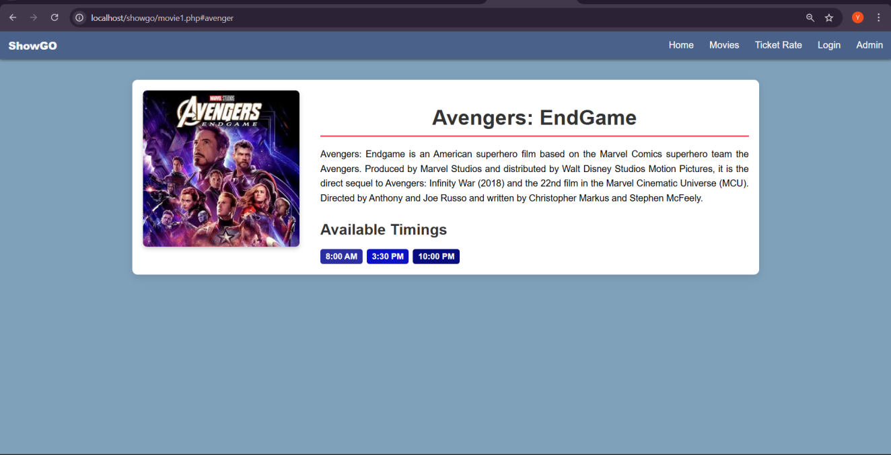

1. Ticket Rates

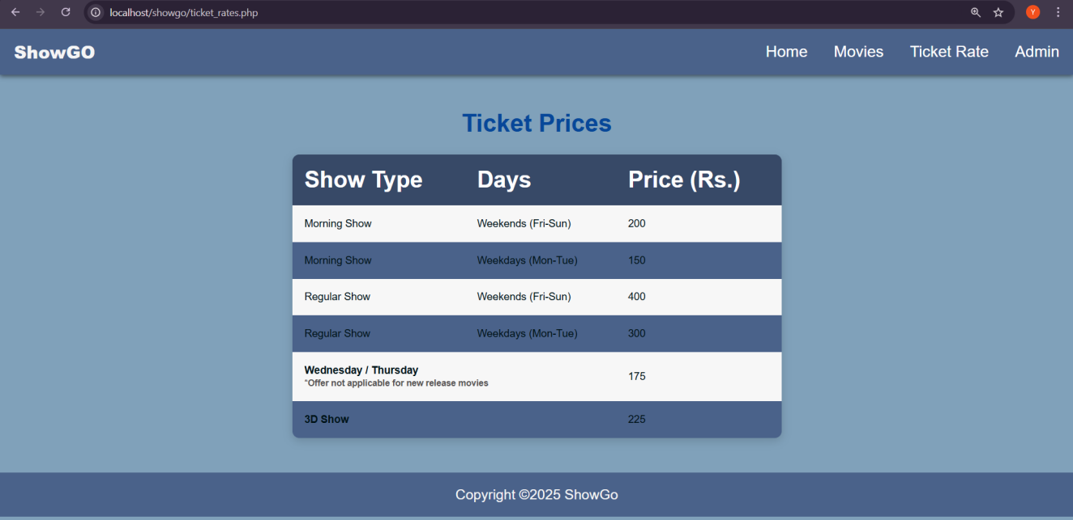

1. User Login

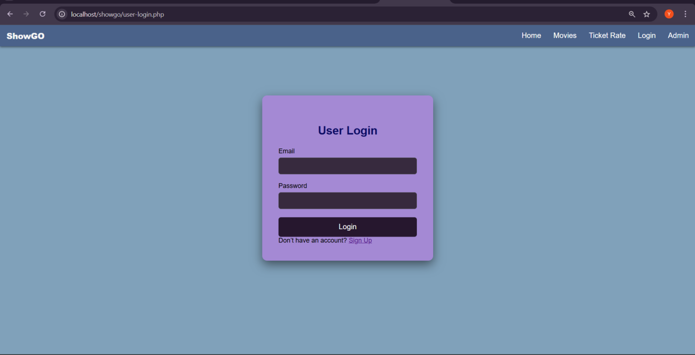

1. User Signup

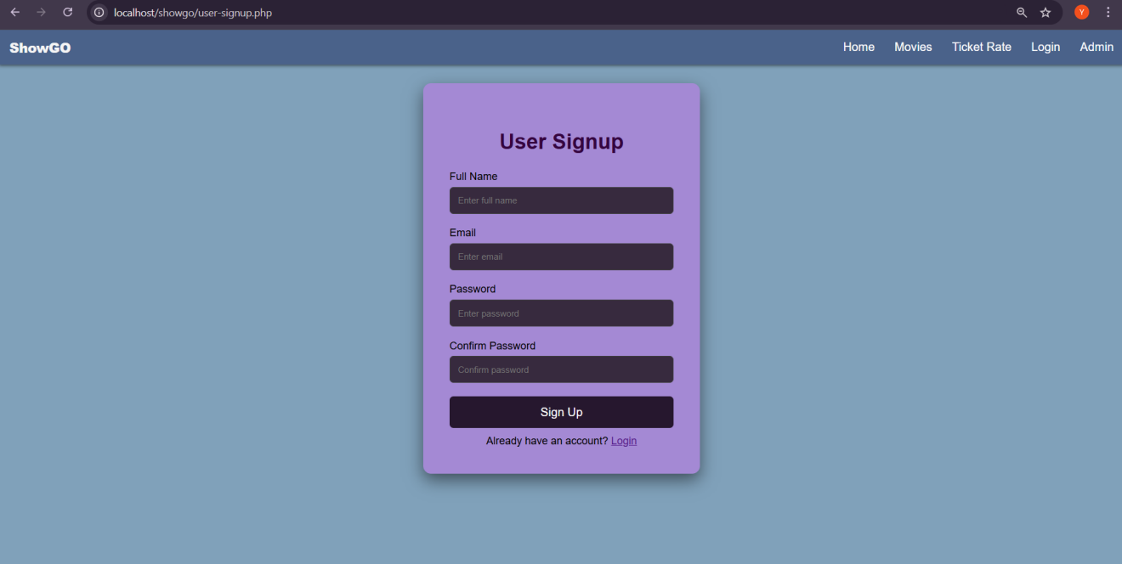

1. Book Seats



1. Payment

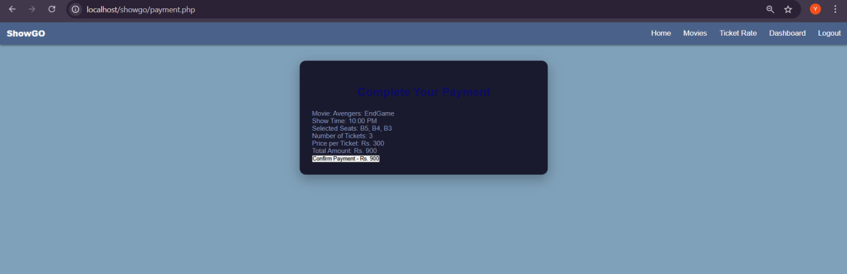

1. Ticket Receipt

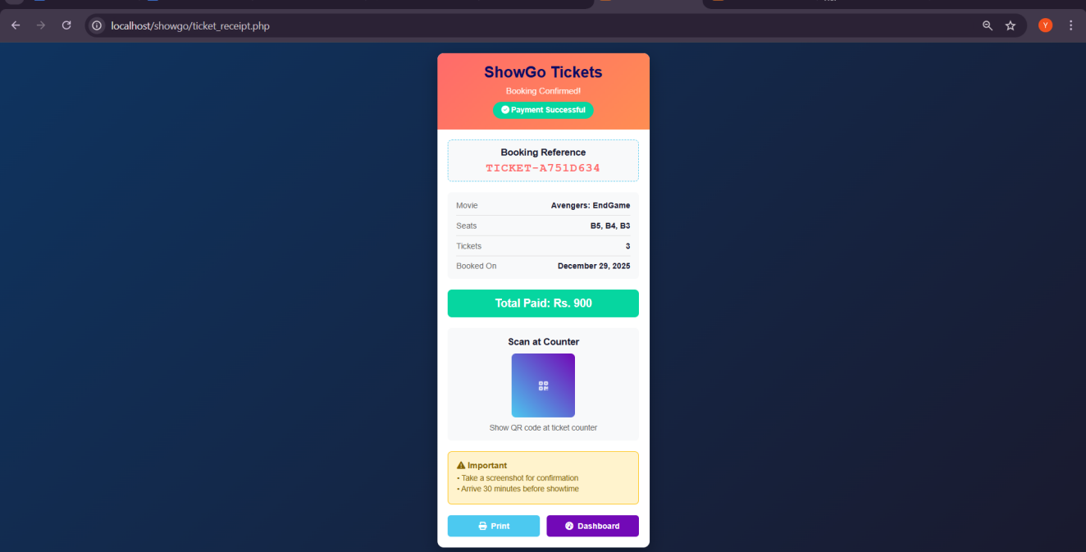

1. User Dashboard

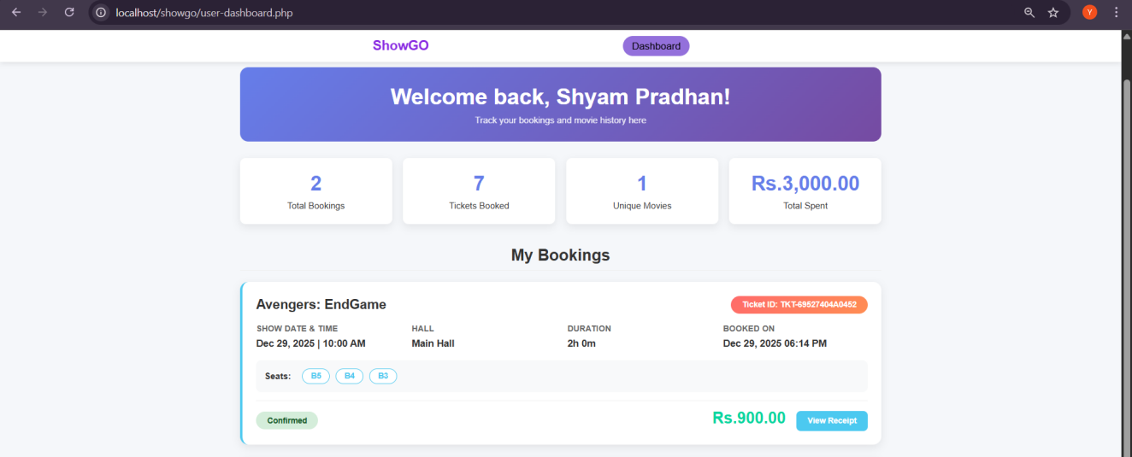

1. Admin Login

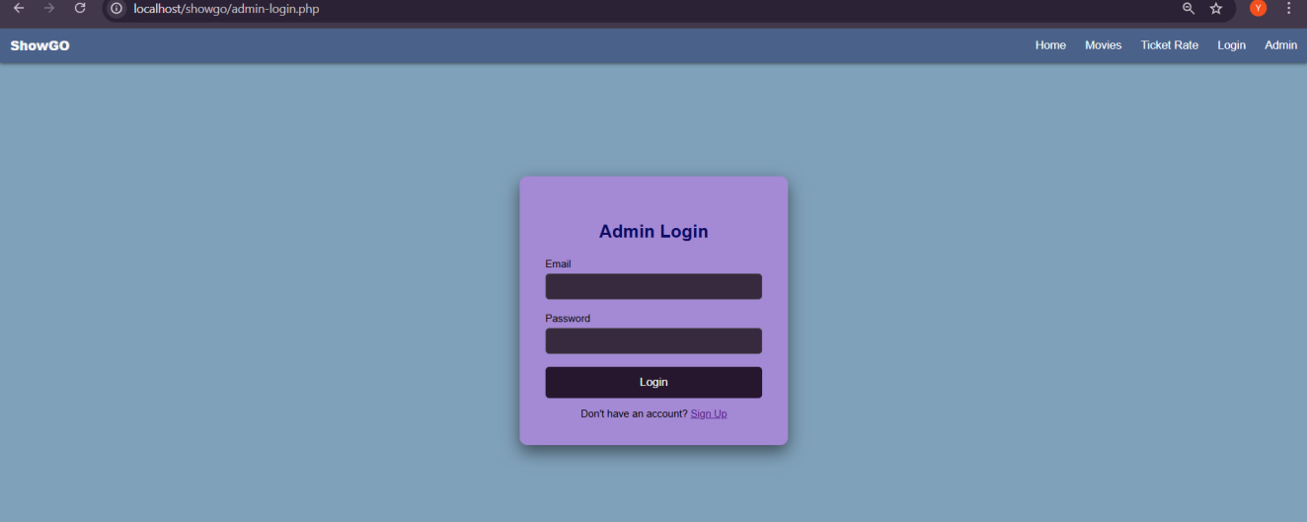

1. Admin Signup

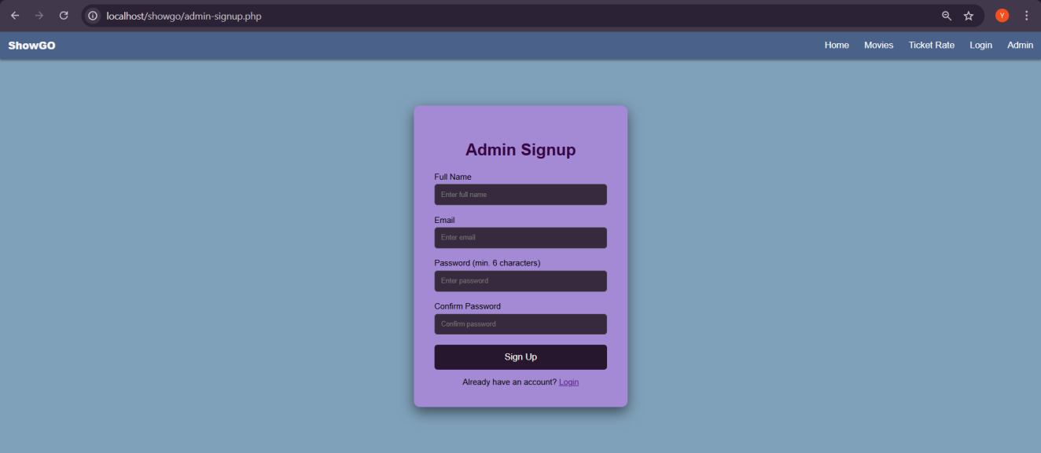

1. Admin Dashboard

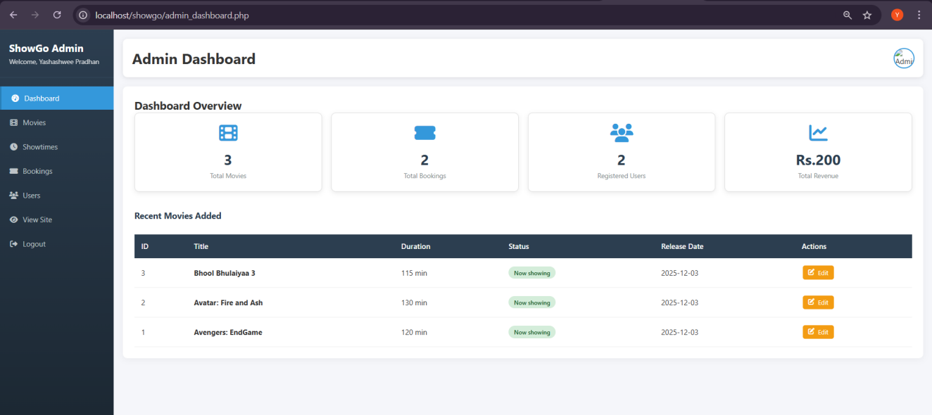

1. Movies Management

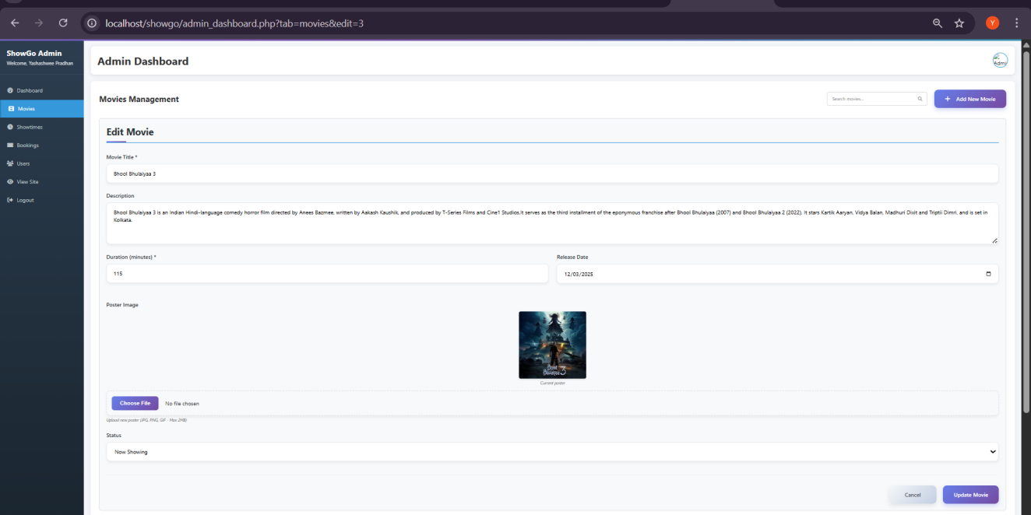

1. Show-time Management

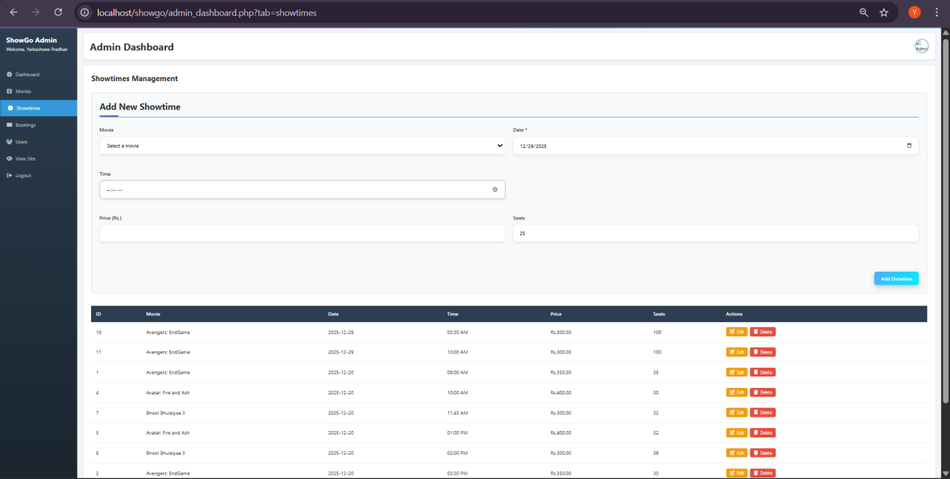

1. Booking Management

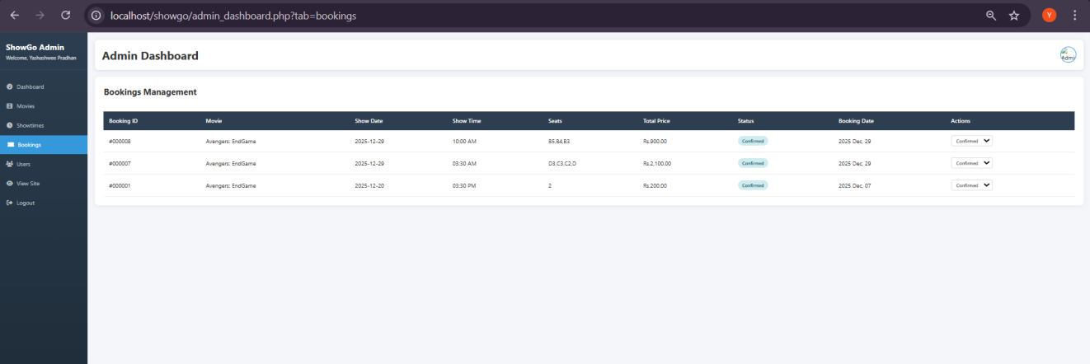

1. Users Management

